Ayham Abdallah Mohamed odeh  Electrical Engineering, Qalqilya, Palestine  +970 598521569, E-mail: Ayham@pass.com | 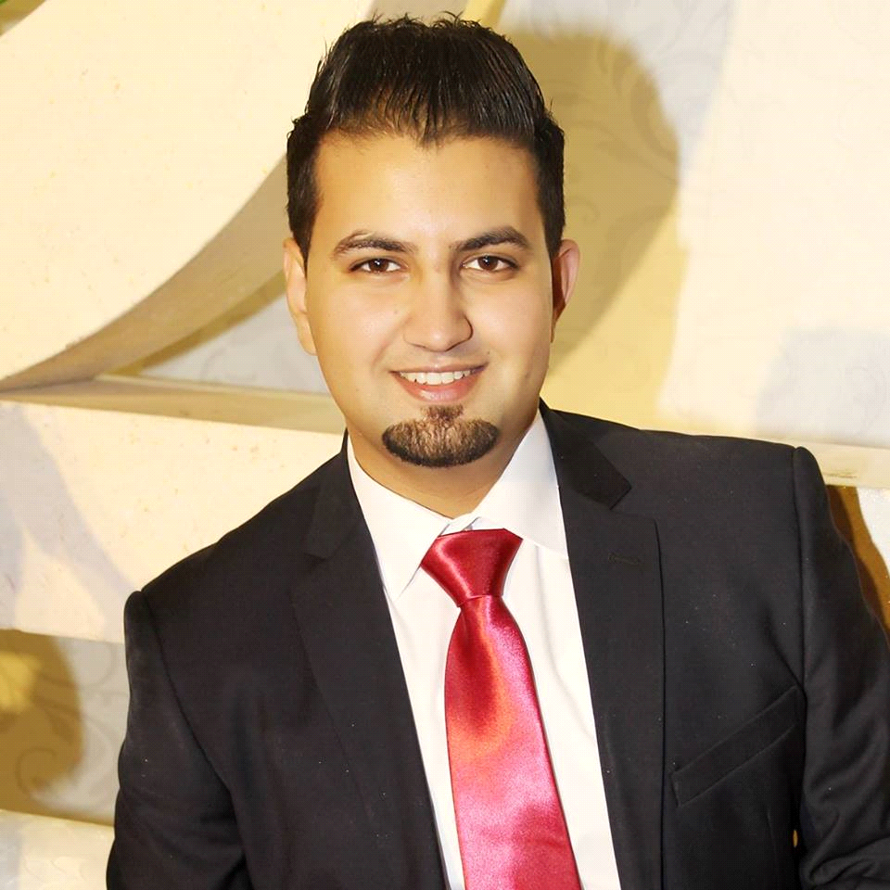

Education:
- BSc. Electrical Engineering, An-Najah National University, Palestine, 2011 – 2015.
- Graduation Project:
Graduation Project(1):
(Wireless Power Transfer)
Graduation Project(2):
( Design And Implement a 2-Ghz Oscillator Using Advanced Design System Software)
.
- General Secondary Certificate Examination (GSCE), Habla Secondary School, Qalqilya, Palestine 2010-2011.
Scientific Field.
GSCE Score: 91.4.
Work Experience:

- work at Al-istiqlal University in the city of Jericho in the field of engineering At the beginning of 2016 to the current time.
- networks and machinery Systems Installation, repairing and upgrading, Free Business, Palestine, 2015-2016.
- Call Center, REACH-Paltel Group, Nablus, Palestine, July- October 2012.
Scientific Activities:
- Investigation of LiFi Solution.
Designing a hardware circuit to implement the LiFi technology as an indoor solution for high-speed wireless communication using Light Density Modulation.
(Documentation available upon request).
- Noise Cancellation Approach Using Spectrum Subtraction and Bartlett Window.
Paper written as a Speech Processing Course Project, and an implementation using Matlab .
(Documentation available upon request).
Computer Skills:
- Expert user of Ms-Office(including Word, Excel, PowerPoint, Publisher).
- Expert user of Matlab and Simulink.
- Excellent in Programming Languages including C++, Java and Visual Basic.
- Ability to program microcontrollers using Assembly Language and PicC Language .
- Expert user of Cisco Packet Tracer (Network Simulation and Design).
- Expert in Cisco Routers and Switches configuration using CLI commands.
- Expert user of graphic design and video montage softwares including Adobe Photoshop, Illustrator and Adobe Premier.
- Expert user in Audio editing software (Sony Sound Forge).
- Familiar with circuit and microcontroller simulation softwares including Multisim, Pspiece and Proteus.

Other Skills:
- Social Skills:
Very good communication skills, acceptance of other opinions, good team worker, perfect leadership skills, work under pressure, very good skills in talking in front of large audience, High Potentials in fast learning and Ease of Understanding.
- Languages:
English: good in Speaking, Reading, Listening and Writing.
Arabic: Native Language.
- Very good Report writing Skills.
- Very good Work Paper writing and Preparation.
Training:
- 160 Hours Training course, Company Akhras control, Nablus Palestine, 2015.
- 160 Hours Training course, Super Link, Nablus, Palestine, 2015.
Certificates:
- CCNA Routing and Switching: Connecting Networks.
Cisco Academy, Hisham Hijawi College of Technology, Palestine,
Final Exam Score: 84.3
- CCNA Routing and Switching: Scaling Networks.
Cisco Academy, Hisham Hijawi College of Technology, Palestine, 2/5/2015.
Final Exam Score: 91.3.
- CCNA Routing and Switching: Routing and Switching Essentials.
Cisco Academy, Hisham Hijawi College of Technology, Palestine, 25/4/2015.
Final Exam Score: 93.5.
- CCNA Routing and Switching: Introduction to Networks.
Cisco Academy, Hisham Hijawi College of Technology, Palestine, 14/3/2015.
Final Exam Score: 98.2.
- CCNA Security 2015.
Cisco Academy, Hisham Hijawi College of Technology, Palestine, 8/12/2015, 60 Credit Hours
- Hardware maintenance Office.
Hijawi Academy, Hisham Hijawi College of Technology, Palestine 9/3/2014 -22/4/2014.
40 Credit Hours.
Workshops:
- Leadership.
- Team Working.
- Problem Solving.
- Networking, Effective Communication.
- Positive impact in the local community.
- Adobe Premier (Video Montage).
American Corner, An-Najah National University, Palestine, 17/6/2013 - 30/6/2013.
- Join the World: Recrear Apply.
Engineering Electrical Center, Faculty of Engineering, An-Najah National University, Palestine, 4/1/2011 - 16/1/2011.
Workshops:
- Resume Building in American and European Union.
- How to shine in your cover letter.
- Building Partnerships with Universities.
- Improving Your Interview Skills.
- Culture Shock While Studying Abroad.
- Applying to Master’s and PhD Programs.
- How to Start Your Own Community Projects.
- How to Build Your Professional Network.
- Effective Blogging in English.
- Telling Your Story Through Creative Expression.
- Certificate of Participation, Injaz Palestine.
Engineering Electrical Center, Faculty of Engineering, An-Najah National University, Palestine, January 2011.
Workshops:
- How to be a Leader.
- Project of Life.
Conferences:
- MESBC (Middle East Student Branch Congress).
AUB (American University of Beirut), Lebanon, 28/5/2014 - 1/6/2014.
Certificate of attendance as treasurer of IEEE Najah Student Branch.
Won the DOA (Delegation of Aspiration) for hosting the next MESBC Conference(2015).
- Forth Annual Power Conference.
Engineering Association, Palestine, 26/1/2012 – 27/1/2012.
Certificate of attendance as a volunteer.
Voluntary Work:
- Volunteer at Public Relations, An-Najah National University, Palestine, 2013 – 2014.
- treasurer at IEEE Najah Student Branch, Faculty of Engineering, An-Najah National University, 2013-2014.
- Volunteer at IEEE(Institute of Electrical and Electronic Engineers) Najah Student Branch, Faculty of Engineering, An-Najah National University, 2013-2014.
- Volunteer at Engineering Communication Center, Faculty of Engineering, An-Najah National University, Palestine, 2011 – 2013.
Hobbies:
Swimming, Fixing computers and electronic devices, Photography, Listening to Classical Music.

References:
- Dr.Ahmed Masri, Lecturer in Engineering, Faculty of Engineering, An-Najah National University, , Mobile: +970568756022, Email: ahmed.masri@najah.edu.
- Dr. Saed Tarapiah, Assistant professor at communication Engineering Department, Faculty of Engineering, An-Najah National University, Tel: +970 9 2345113 ext 2189, Email: S.TARAPIAH@NAJAH.EDU

